ICT286 Task Breakdown List
Name of the member: Stevanus Setiadi Soejanto
My partner for this assignment is Saai Aditi PR and Saw Gwe Aw
I believe that my contribution to this assignment is 33.3%.
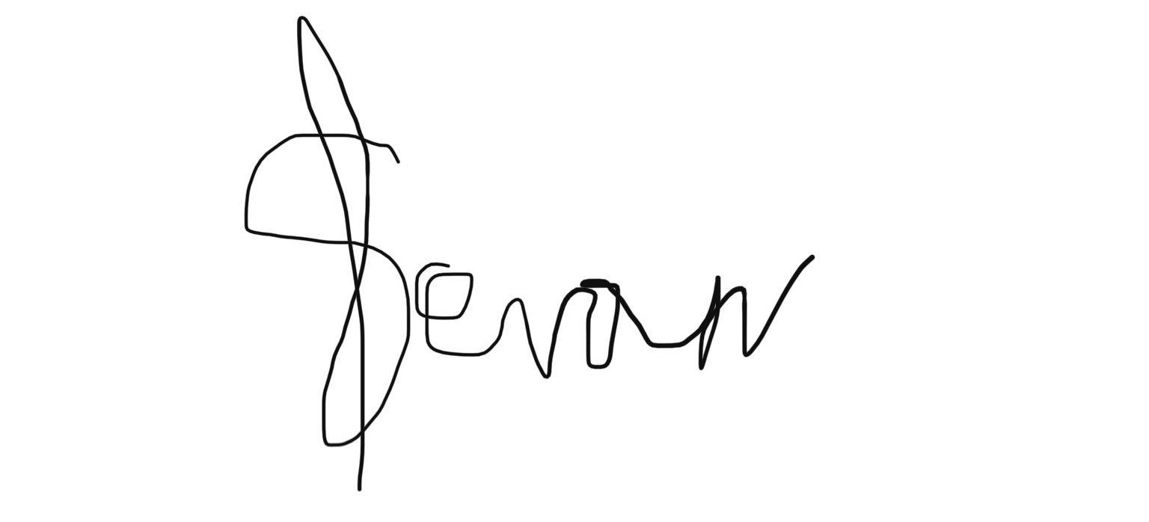
Signature: Date: 20-November-2020
Task allocated to me or completed by me (you may add as many rows below as you need) | Allocated completion time | Actual completion time | Number of lines of code or number of words if it is not code | Comments
Company.docx | 20-November-2020 | 16-November-2020 | 1475 words | It is a document describing fictious online trading company
Task B cordova front end packaged for android documentation | 20-November-2020 | 20-November-2020 | 2380 words | It is a documentation of the Task B cordova front end packaged for android documentation
All of task B which is a cordova front end packaged for android | 20-November-2020 | 19-November-2020 | Outlined below | -
db.js | 20-November-2020 | 19-November-2020 | 227 lines | Contain functions which is related with database handling.
index.js | 20-November-2020 | 19-November-2020 | 130 lines | Contain functions which is called by HTML files to execute db.js functions.
about.html | 20-November-2020 | 19-November-2020 | 73 lines | Contain information about the company.
admain.html | 20-November-2020 | 19-November-2020 | 48 lines | It is a main page which is accessed by staff.
contact.html | 20-November-2020 | 19-November-2020 | 58 lines | It is a page for user to send message to the company
index.html | 20-November-2020 | 19-November-2020 | 43 lines | It is a page which can be accessible by everyone.
login.html | 20-November-2020 | 19-November-2020 | 64 lines | It is a login page for a registered user or staff. It also have a regristration which can make user to register themselves.
main.html | 20-November-2020 | 19-November-2020 | 48 lines | It is a main page for registered user after login.
payment.html | 20-November-2020 | 19-November-2020 | 46 lines | It is a page which contain payment method and is accessed after customer finish choosing a product which they are going to buy.
product.html | 20-November-2020 | 19-November-2020 | 55 lines | It is a product page for user who have logged in. In addition, they can also do purchase and payment method.
producti.html | 20-November-2020 | 19-November-2020 | 52 lines | It is a product page which can be accessed by everyone. However, they can only explore the products without being able to buy it.
success.html | 20-November-2020 | 19-November-2020 | 46 lines | It is a page which is displayed after payment transaction is done.

